Final Year Project


CareFirst Proposal

FYP Team
Ali Anjum (22F-3734)
M. Makki (22F-3631)
Umer Maqbool (22F-3837)

Supervised by
Muhammad Haseeb Arshad

Department of Computer Science
National University of Computer and Emerging Science Chiniot, Pakistan
2026

Anti-Plagiarism Declaration

This is to declare that the above publication produced under the:

Title: CareFirst: A web-based Smart Healthcare Appointment & Diagnostic Installment Management Platform

is the sole contribution of the author(s) and no part hereof has been reproduced on as it is basis (cut and paste) which can be considered as Plagiarism. All referenced parts have been used to argue the idea and have been cited properly. I/We will be responsible and liable for any consequence if violation of this declaration is determined.

Date: ______________

Student 1

Name: Ali Anjum Signature: ___________________

Student 2

Name: M. Makki Signature: ___________________

Student 3

Name: Umer Maqbool Signature: ___________________

Abstract
In Pakistan, many people face problems when trying to book doctor appointments and manage medical test expenses. Appointments are often manual, test prices are unclear, and many patients cannot afford expensive diagnostic tests at once. This project proposes a web-based healthcare platform that helps users book physical doctor appointments, search and compare diagnostic labs, and manage high-cost medical tests through an installment tracking system.
The platform does not provide online consultation and does not handle or transfer money. All payments are made directly to diagnostic labs, and the system only records payment proofs for tracking purposes. User identity is verified using CNIC, and installment usage requires acceptance of a digital legal agreement. The system also sends reminders for upcoming payments and supports legal notice facilitation in case of repeated default.
Additional features include true cost comparison using distance, Urdu text-to-speech for better understanding, and a community support registry that helps verified needy patients connect with lab welfare support without the platform collecting donations. The system acts only as a facilitator and record keeper.

Table of Contents
1. Vision Document 1
1.1. Introduction 1
1.1.1. Problem Statement: 1
1.1.2. Objectives 1
1.2. Motivation 2
1.3. Overview 2
1.4. Functionality 3
1.4.1. User Registration & Verification 3
1.4.2. Physical Appointment Booking 3
1.4.3. Diagnostic Test Search & Lab Comparison 3
1.4.4. Installment Request & Legal Agreement 4
1.4.5. True Cost Optimizer 4
1.4.6. Digital Wallet & Payment Tracking 4
1.4.7. Notification & Default Handling 4
1.4.8. Payment Proof Verification 4
1.4.9. Urdu Text-to-Speech Module 4
1.4.10. Community Support Registry 4
2. Tools and Technologies 5
2.1. Web Technologies 5
2.2. GitHub 5
2.3. Visual Studio Code 5
3. Required hardware and Software resources 5
3.1. Hardware 5
3.2. Software 6
4. High Level Diagram 7
5. Timeline 8
6. References 9

1

1. Vision Document

1.1. Introduction

1.1.1. Problem Statement:

In Pakistan, healthcare access is affected by poor appointment management, lack of transparency in diagnostic test prices, and financial difficulties faced by patients. Many labs charge different prices for the same test, and patients often select a lab based on price alone without considering travel cost. Expensive diagnostic tests are also difficult to afford due to upfront payment requirements.
There is no single platform that combines physical appointment booking, diagnostic test search, lab comparison, installment tracking, and identity verification in a safe and controlled manner. This creates delays in diagnosis, financial stress for patients, and trust issues for lab

1.1.2. Objectives

- To develop a web-based platform for booking physical doctor appointments.
- To provide transparent diagnostic test search and lab comparison by city, price, and rating.
- To enable optional installment-based payment tracking for expensive diagnostic tests.
- To implement CNIC-based user verification for accountability.
- To calculate the true cost of a test by adding travel cost.
- To introduce a digital wallet as a ledger, not a financial processor, for installment tracking.
- To provide automated reminders and legal notice facilitation for overdue payments
- To improve understanding through Urdu text-to-speech.
- To support underprivileged patients through a community support registry.

2

1.2. Motivation

Healthcare affordability and transparency remain critical issues in Pakistan. Many patients delay or skip diagnostic testing due to high costs and lack of flexible payment options. At the same time, diagnostic labs face financial risks when offering deferred payments.
This project is motivated by the need to bridge this gap using a technically sound, legally cautious, and ethically responsible system that benefits patients, labs, and healthcare providers without acting as a bank, medical authority, or charity.

1.3. Overview

The proposed system functions as a healthcare service facilitation platform. Users can book physical appointments, receive test recommendations, search and compare labs, and optionally opt into an installment tracking feature. The platform verifies users through CNIC, generates digital legal agreements, tracks installment progress, and sends payment reminders.
All diagnostic payments are made directly to labs, while the platform charges a separate fixed service fee for providing its coordination and tracking services..

1.4. Functionality

The system workflow includes user verification, appointment booking, test discovery, installment request processing, wallet based tracking, payment proof verification, and default handling. The platform acts strictly as a facilitator and record keeper.
The project would have the following features:

3

1.4.1. User Registration & Verification
Users register on the platform and must upload CNIC details. Verification is performed by the administrator before installment features are enabled. This step ensures accountability and reduces misuse.

1.4.2. Physical Appointment Booking
Users book clinic appointments with doctors. Users find doctors based on specialty, location, and availability. No online consultation is provided.

1.4.3. Diagnostic Test Search & Lab Comparison
Users independently search for diagnostic tests and view available labs with pricing, location, and ratings. Test booking decisions remain fully user controlled.

1.4.4. Installment Request & Legal Agreement
For high cost tests, users may request installment tracking. A fixed platform service fee is paid separately. A digital legal agreement outlining installment terms is generated and verified by the admin.

1.4.5. True Cost Optimizer
The system calculates the shortest route from the user to each lab and estimates travel cost. This travel cost is added to the test price to show the true cost, helping users choose the most cost-effective option.

1.4.6. Digital Wallet & Payment Tracking
A digital wallet records installment schedules, payment status, and overdue flags. The wallet does not store money. Users upload payment proofs after paying labs directly.

4

1.4.7. Notification & Default Handling
Automated email and SMS reminders are sent before and after due dates. In case of persistent default, the system facilitates legal notice issuance through a registered lawyer.

1.4.8. Payment Proof Verification
Users pay labs directly and upload payment receipts. Admin verifies these proofs and updates the wallet status.

1.4.9. Urdu Text-to-Speech Module
Important information such as legal agreements and report summaries can be listened to in spoken Urdu. This helps users who have difficulty reading English.

1.4.10. Community Support Registry
Users who cannot afford tests can apply for support by uploading utility bills and bank statements. Admin verifies financial need. Verified cases appear anonymously in the registry.
Other users may choose to donate externally to lab welfare accounts or hospital charities. The platform does not collect money. When welfare support is available, the admin assigns the needy patient to a lab and generates an authorization slip for test execution.

2. Tools and Technologies

2.1. Web Technologies



A web-based healthcare service platform developed using the MERN stack to enable appointment booking, laboratory search and comparison, CNIC-based user verification, digital agreement generation, installment tracking, and payment reminders.

5

2.2. GitHub

A version control tool that will help manage changes in the project code, provide backup, and enable organized collaboration throughout the development process.

2.3. Visual Studio Code

Lightweight and powerful source code editor that supports multiple languages and extensions. It offers debugging and intelligent code completion, making it ideal for development in this project.

3. Required hardware and Software resources

3.1. Hardware

Following development, PC is required to develop this project

Hardware | Specifications
Operating System | Windows 10/11 or Linux (64-bit)
Memory (RAM) | 8 GB minimum, 16 GB recommended
Storage | 256 GB minimum (SSD preferred)

6

3.2. Software

Following software’s are required for the development of this project

Software | Purpose
GitHub | Version control
Visual Studio Code | Development environment
SSMS/MongoDB | Database management
Web Framework | Frontend/Backend development
Web Browser | Application testing

7

4. High Level Diagram

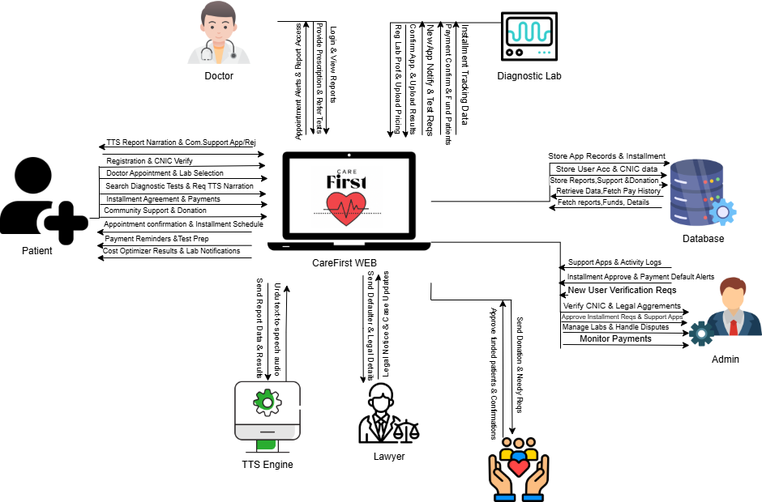
Architecture Diagram

8

5. Timeline

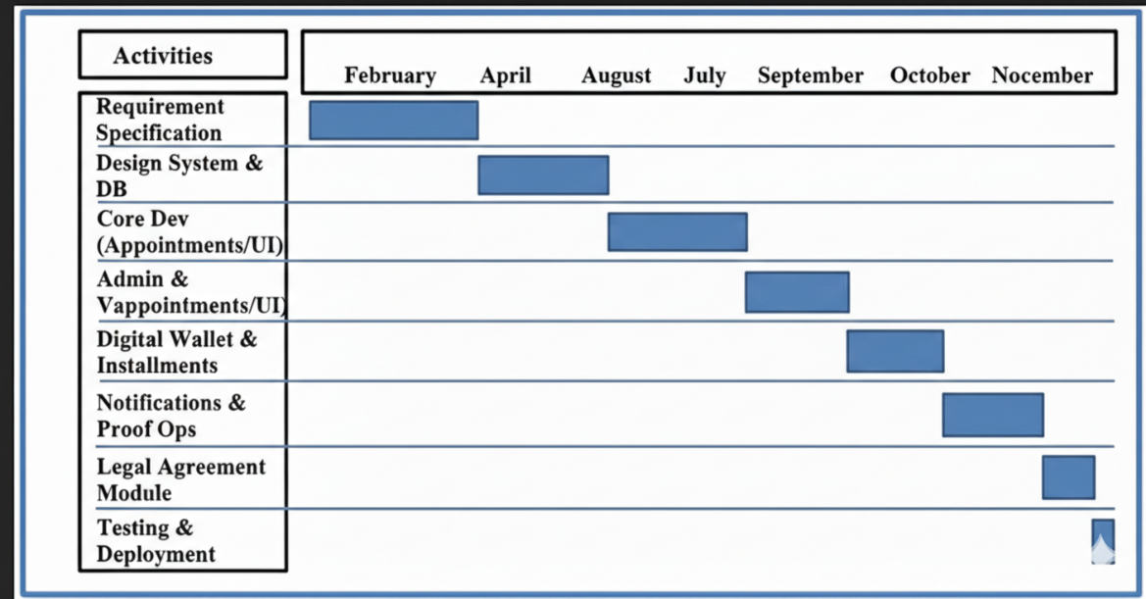
Timeline

9

6. References

● World Health Organization. (2023). Digital health systems and service delivery. https://www.who.int/health-topics/digital-health
● Pakistan Telecommunication Authority. (2022). Digital identity and verification frameworks in Pakistan. PTA. https://www.pta.gov.pk
● Khan, M., & Ahmed, S. (2021). Web-based healthcare management systems: Design and implementation. International Journal of Computer Applications, 174(22), 15–21. https://doi.org/10.5120/ijca2021921305
● Shaikh, F., & Ali, R. (2020). Challenges of healthcare affordability in Pakistan. Journal of Public Health Policy, 41(3), 356–368. https://doi.org/10.1057/s41271-020-00235-9

